**LAB 5**

**OBJECTIVE**

To implement different kinds of filters used in image processing.

**THEORY**

A Laplacian filter is an edge detector used to compute the second derivatives of an image, measuring the rate at which the first derivatives change. This determines if a change in adjacent pixel values is from an edge or continuous progression. Laplacian filter kernels usually contain negative values in a cross pattern, centered within the array. The corners are either zero or positive values. The center value can be either negative or positive.

Mean filtering is a simple, intuitive and easy to implement method of smoothing images, i.e. reducing the amount of intensity variation between one pixel and the next. It is often used to reduce noise in images.The idea of mean filtering is simply to replace each pixel value in an image with the mean (average) value of its neighbors, including itself.

The geometric mean filter is an image filtering process meant to smooth and reduce noise of an image. It is based on the mathematical geometric mean.The geometric mean filter is most widely used to filter out Gaussian noise. In general it will help smooth the image with less data loss than an arithmetic mean filter.

In the harmonic mean method, the intensity value of each pixel is replaced with the harmonic mean of intensity values of the pixels in a surrounding region. The harmonic mean filter is better at removing Gaussian type noise and preserving edge features than the arithmetic mean filter. The harmonic mean filter is very good at removing positive outliers.

**CODE**

% Program 1 : Different Filters

% Laplacian filter

newImg = imread('image.jpg');

figure(1);

imshow(newImg),title('Original Image');

H=fspecial('laplacian');

blurred= imfilter(newImg,H); %Apply Laplacian Filter

figure(2),imshow(blurred);

title('Edge Detected Image')

% Mean filter

im=imread('image.jpg');

G=imnoise(im,'Gaussian',0.0005,0.0019);

figure,

imshow(G),title('Image with Gaussian noise');

figure;

h=fspecial('average',3);

F=imfilter(G,h);

imshow(F),title('Gaussian Noise Removed')

% Geometric filter

[a,map]=imread('image.jpg');

b=im2double(a);

w=fspecial('Gaussian',[3,3]);

geom=exp(imfilter(log(b),ones(3,3),'replicate')).^(1/3/3);

fname=imfilter(b,w,'replicate');

figure,imshow(fname),title('Geometric Mean Filter');

% Harmonic filter

Im=imread('image.jpg');

Im=double(Im);

S_=size(Im);

Mask=7;

for i=1:S_(1)

j=1;

while(j<S_(2)-Mask)

T(1:Mask)=Im(i,j:j+(Mask-1));

Data=harmmean(T);

Im(i,j+1)=Data;

j=j+1;

end;

end;

figure(6),imshow(uint8(Im)),title('Harmonic Mean Filter');

**OUTPUT**

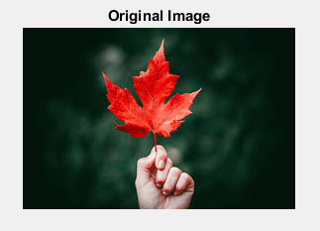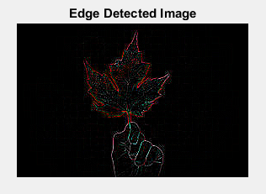

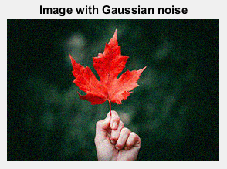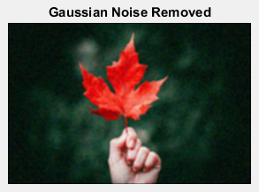

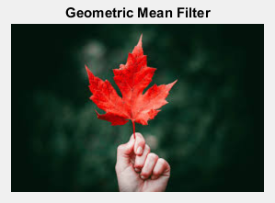

**CONCLUSION**

In this lab, I got familiar with different kinds of filters in image processing and implemented them in matlab.